Your monthly guide to school news, information, and events.
Maryland State Department of Education License Number 32975

NASA Goddard Child Development Center’s
The Lunchbox Press
DEC | 2022

Comets Culture Celebration
Dec 12

Little Dippers Culture Celebration
Dec 13

Milky Way Culture Celebration
Dec 14

Shooting Stars & Constellations Culture Celebration
Dec 15

Curriculum Break
Dec 19-23

Winter Break—GCDC Closed
Dec 26-Jan 2

Parent Teacher Conferences Jan 3-Jan 11

Science Fair
Jan 17-20
Reducing Challenging Behaviors During Transitions
By The National Association for the Education of Young Children
Transitions are when children move from one activity to another. Everyday transitions include arriving at an educational setting from home, moving from dinner to playtime, finishing playtime and cleaning up, brushing teeth, and then taking a bath, and going from bath time to bedtime. Transitions can be
difficult for some parents, particularly when taking their young children out into the community, picking them up from educational settings, or moving
between activities and routines at home. For some children, transitions may
be frustrating or may provoke anxiety, and they may lead to challenging behaviors. In this article, we adopt the definition of “challenging behavior”
provided by the Center on Social and Emotional Foundations for Early Learning:

- Any repeated pattern of behavior that interferes with learning or engagement in pro-social interactions with peers and adults.

- Behaviors that are not responsive to the use of developmentally appropriate guidance procedures.
- Prolonged tantrums, physical and verbal aggression, disruptive vocal and motor behavior (e.g., screaming, stereotypy), property destruction, self-injury, noncompliance, and withdrawal.
Difficulty with transitions can occur for a number of reasons, such as when children are tired, hungry, confused, or not ready to end an activity. Difficulty
with transitions is also common when children have communication delays, limited social and emotional skills, or intellectual disabilities (Hemmeter,
Ostrosky, & Corso 2012). By considering children’s needs and abilities and planning accordingly, parents can avoid problems at transition times. For example, instead of racing from one errand to another on a Saturday
morning, parents might plan a 20-minute break to play with their children between stops. Put yourself in your child’s shoes and look at the world from
their vantage point as you consider how to show your child what to do (“Leo,
put the washcloth like this to scrub your legs.”); how to keep their children busy (“Alex, while we wait for the server to bring our food, why don’t we look
at these books we brought along?”); and how to prepare your children for what comes next (“Jade, after we go to the bank, we will stop by the park for
some crackers and juice and play on the slide for a bit.”). To ease transitions, parents can:
  - Identify skills children can do independently and help your child to develop skills they are still learning.
  - Teach your child a variety of emotion words to help them better communicate what they are feeling during transitions.
  - User “first, then and next” statements to help your child prepare for the transitions.

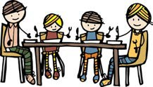
GCDC’s Annual Family Dinners

2022-2023 GCDC
Association Board of Directors

Marilyn Toliver
President

Martha Wawro
Vice-President

Molly Jackson
Registrar

Claribel Ferrolino
Treasurer

James Harrington
Education Advisor

Jeff Steir
Facilities Advisor

Erin Roberts
Secretary

Brad Cenko
Member At Large

Stephanie Arcido
Member At Large

Robin Mahoney
GEWA Operations Manager

GCDC Family’s That Have Questions or Concerns About Our Program May Visit Board Meetings for the first 10 minutes are scheduled.

This month, as a way to celebrate customs and traditions, each
class will have a family dinner. Families are asked to bring a prepared dish that is reflective of their culture/family traditions.
Food items may be homemade or store-bought; however, fast foods are not allowed. Volunteer credit will not be awarded for this activity.

To sign up to bring a dish, visit your classroom link listed below:

Because the celebration includes homemade food, families must make their child's plate. For your child’s safety, the Teachers will
not do this. If you are unable to attend, please identify a parent to stand in for you during meal service.

Before the meal, the children will share a brief performance. The performances will begin promptly at 3:30 and usually last less than 10 minutes. If you do not want to miss the performance.
Classroom Sign-up Links
Comets: https://signup.com/go/LAesncg

Constellations: https://signup.com/go/DFSUzok

Shooting Stars: https://signup.com/go/SvEncim

Milky Way: https://signup.com/go/NUQuWZJ

Little Dippers: https://signup.com/go/sRzJNbi

Outdoor Play Reminders: Outdoor play is an integral part of our program. Weather permitting, we are required to provide at least 2 hours of outdoor play each day. On other days, the amount of time the children spend outdoors is determined by the weather. Families can find this information in the parent handbook. Please note that we cannot exclude children from outdoor play at parent request. The typical rule of thumb is that children should be well enough to participate in the full
daily schedule (to include outdoor play) if they are in attendance. In support of this requirement, children
must have a coat, hat, and gloves available each day. Additionally, children need well fitting, closed toe shoes that are appropriate for the weather.
Please help us throughout this winter season by ensuring that your child is prepared for outdoor play each day.

Children’s Literature Recommendations

Indoor play places that you and your child may enjoy this winter.

Badlands Playspace http://badlandsplayspace.com

Play and Learn Superstore https://www.playnlearn.com

During this Combined Federal Campaign (CFC) Season, consider NASA Goddard Child Development Center (GCDC) as your charity of choice. NASA GCDC is committed to providing financial assistance to qualified NASA/GSFC families through income-
Love You All Day Long by Francesca Rusackas
The Kissing Hand by Audrey Penn
Llama Llama Misses Mama by Anna Dewdney
I Miss You, Stinky Face by Lisa McCourt
Mama Always Comes Home by Karma Wilson
Whose Mouse Are You? by Robert Kraus
No Matter What by Debi Gliori
Oh, My Baby, Little One by Kathi Appelt
Owl Babies by Martin Waddell
When Mama Comes Home Tonight by Eileen Spinelli

based scholarships. To that end, all funds received
Articles About Separation

through the Combined Federal Campaign will be used to support the GCDC
Scholarship Fund. Persons interested in supporting our scholarship fund
Anxiety

https://kidshealth.org/en/parents/ sep-anxiety.html
https://tinyurl.com/y8fef3u6

should identify our school using the
https://tinyurl.com/yb2r2z2t

CFC Code 76902. For more information about CFC, visit www.cfcnca.org

https://tinyurl.com/ybg5d95w

Newsletter Editor
Leona Adams.
GCDC Program Director

Contributors:
Sign up For A Parent-Teacher Conference

Comets (Jan 3): https://signup.com/go/fmGwDxw

Little Dippers (Jan 4): https://signup.comgo/KvSsJKV

The Milky Way (Jan 5): https://signup.com/go/ZsrkdMe
Shooting Stars (Jan 6): https://signup.com/go/eFUhXOa
Constellations (Jan 9/10):
https://signup.com/go/KoqKPyu

Dominique Ferguson
Lakshini Wijeweera
Kiara Clark

Character Trait of The Month
The character trait of the month is Caring.
Through studying this character trait, we want children to understand that people of
character: Are kind • Are compassionate •
Please note that GCDC

Show they care • Express gratitude • Forgive
will be closed for winter

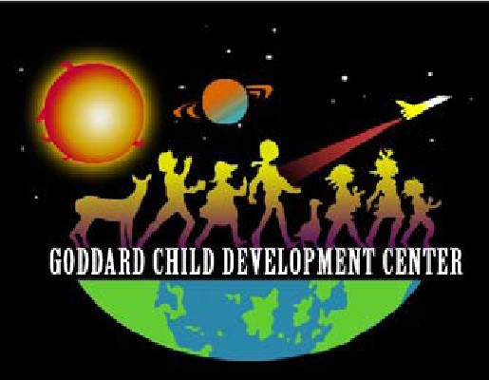
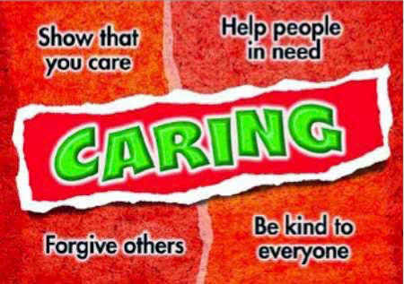
others • Help people in need
break from December 26th-January 2nd.
Note: No tuition is due for the week of December 19th.
We will resume regularly scheduled hours and tuition billing on December 26th for the week of Jan 2nd-6th.

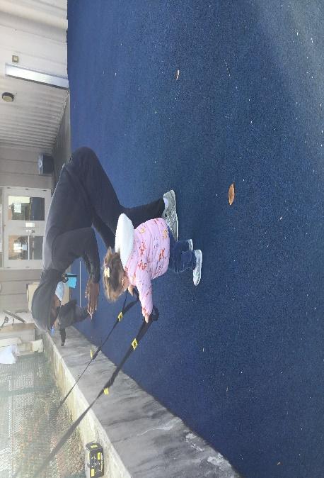
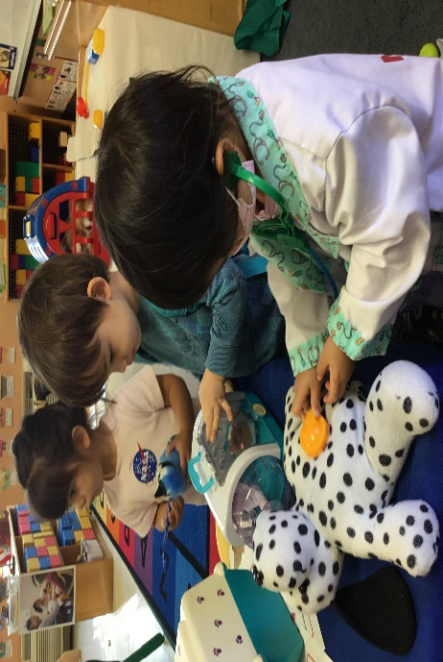
PS 2: Comets
Dramatic Play/Veterinarian
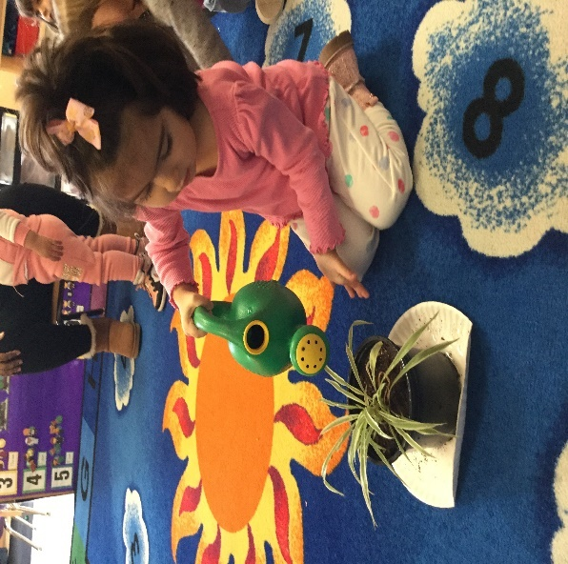
PS2: Little Dippers
Plant Helper
PS 2: Comets
Building Gross Motor Strength

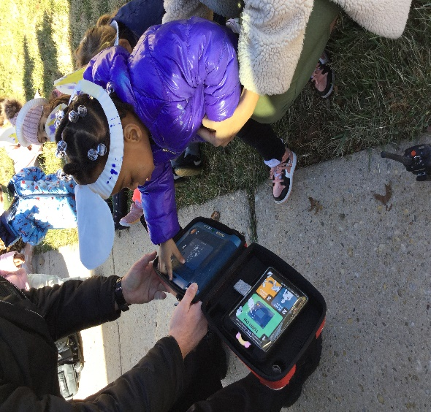
PS 2: Little Dippers
Community Helpers

Current Volunteer Opportunities:
Put together Yoga Mat Holder
Clean/Sanitize Yoga Mats
Put together Wooden Puppet Stand
Catalog New Books for Library
STEM Presenters for January
Support Accreditation Portfolios

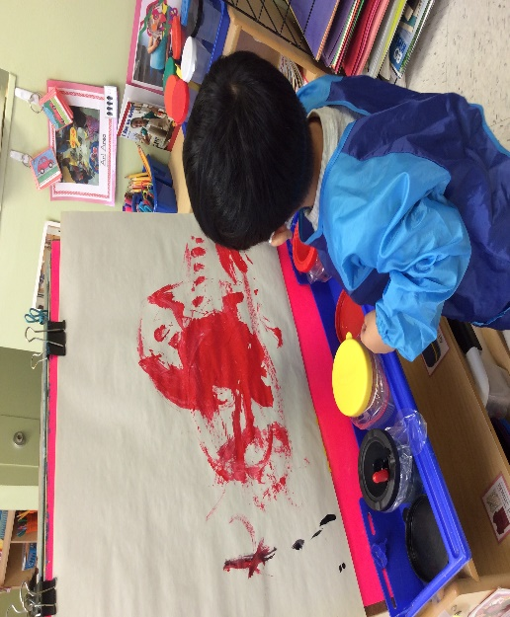
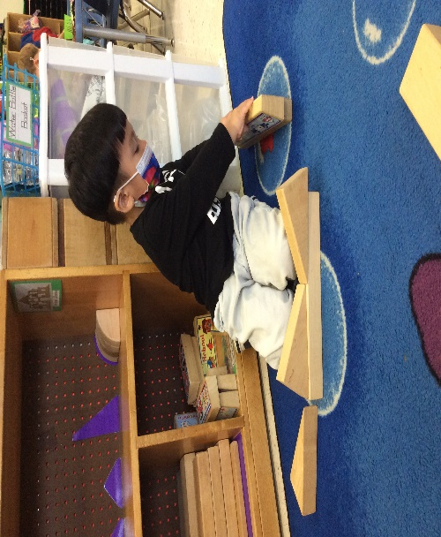
PS3: Milky Ways
Engineering
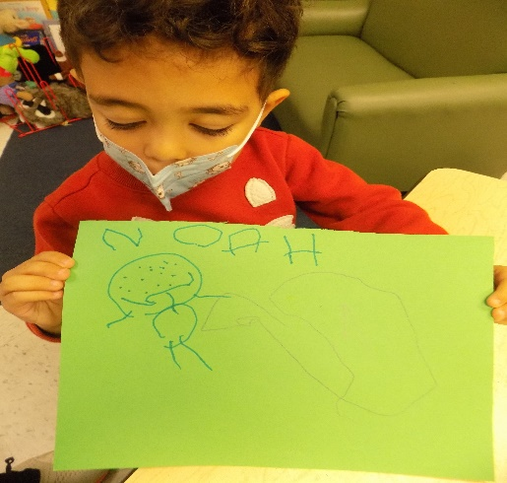
PS4: Shooting Stars
Stages of Writing
Pre-K: Satellites
Science Experiments

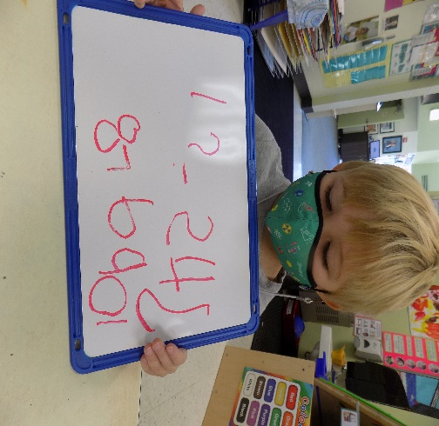
PS4: Shooting Stars
Stages of Writing

The GCDC Annual Parent/ Child Science fair is just around the corner. The Science Fair is required for Pre-K & PS-4 Students and is recommended for PS3 & PS2.

Science Fair Dates
Jan 17th: Shooting Stars Science Fair
https://signup.com/go/wQEtdJt
Jan 18th,20th: Constellations
https://signup.com/go/TBkBFOK
Jan 19th: PS 2’s & 3’s (Make up day)
https://signup.com/go/XBsGRNF

GCDC providers one science board per student.

Each month we will announce the question of the month. These questions are designed to help our students think about the information they may need in an emergency. The question for December is, “What are your parents Full Names? PS2 will need to know both parents first names. PS3 will need to know at least one parents Full Name (first & last) PS4 & Pre-K will need to know both parents’ Full names. Often children learn their parents’ titles and never their names, knowing your name will help in the event of an emergency.

Students will come to the office and answer this question by December 23rd, they will be given a prize from the mystery box.
BIG QUESTION OF THE MONTH?

