c

Your monthly guide to school news, information, and events.
Maryland State Department of Education License Number 32975

NASA Goddard Child Development Center’s
FEB | 2023

The Lunchbox Press

Parent Letters Due
Feb 10

Postal Carrier Visit
Feb 13

Friendship Celebrations
Feb 14

Scholastic Book Fair
Feb 13-17

Federal Holiday: GCDC Closed
Feb 20

100th Day of School
Feb 21

Parent Advisory Committee (PAC) Meeting
Feb

GCDC Airplane Contest
March 10

St. Patrick Day Smoothies March 17

Cookie Sampling Project
March 20-22

Skill 1: Focus & Self Control

By National Association For The Education Of Young Children

Self-control and focus are both important skills for children to practice in order to succeed in school. Children play many fun games and activities in the classroom to help them learn these key life skills.
Here are some that you and your child can do together:
- Swap in different words to favorite songs. Have fun singing songs with a twist. For example, sing “The wheels on the train go round and round” instead of the “Wheels on the bus go round and round”. Does your child notice when you use different words? This game can help children develop listening skills.
- Play games like Simon Says, I Spy, and “I’m thinking of something that starts with the letter…” These games help children practice focusing, paying attention, and remembering rules – all while having fun.
- Play an opposite game. To help your child think flexibly, try playing a game where you do the opposite of what you say; for example, say “Simon says, touch your feet” while you touch your head. Or say you will dance quickly to slow music, then put on fast music and dance slowly.
- Play sorting games while cleaning up. Suggest picking up toys of a particular type, color, or shape. “Let’s pick up the blue crayons first, then the red crayons.” Even cleanup time can be fun and help children focus and think flexibly.
- Try singing a song while waiting in line or at a restaurant. Children who have tools to help them manage their behavior while waiting-like singing a favorite song-are ultimately more successful in pursuing goals with less frustration and distraction.
- Choose books, games, and activities that reflect things your child finds interesting – Whether it’s trucks, flower, or bugs! Children focus best when they care about a topic. What does your child talk about? What themes come up as they play?
These activities are adapted from Ellen Galinsky’s article “Skill 1: Focus and Self Control,” the second in her series the 7 essential Life Skills, in TYC, volume 9, number 3, page 10. (2018)

2022-2023 GCDC
Association Board of Directors

Marilyn Tolliver
President

Martha Wawro
Vice-President

Molly Jackson
Registrar

Claribel Ferrolino
Treasurer

James Harrington
Education Advisor

Jeff Steir
Facilities Advisor

Erin Roberts
Secretary

Brad Cenko

Stephanie Arcido
Members At Large

Robin Mahoney
Acting GEWA Operations Manger

Meetings
Are Scheduled Monthly.

GCDC Family’s That Have Questions or Concerns About Our Program May Visit Board Meetings at Any Time for the first 10 minutes that Meetings are in Session.

Mindful Kids by Whitney Stewart
My Dad is a Pretzel by Baron Baptiste
Yoga Pretzels: 50 Fun Yoga Activities for Kids and Grownups by Baron Baptiste and Sophie Fatus
Harini and Padmini Say Namaste by Amy Maranville and Tim Palin
Good Night Yoga: A Pose-by-Pose Bedtime Story by Mariam Gates and Sarah Jane Hinder
Mindful Kids: 50 Mindfulness Activities for Kindness, Focus, and Calm by Whitney Stewart and Mina Braun
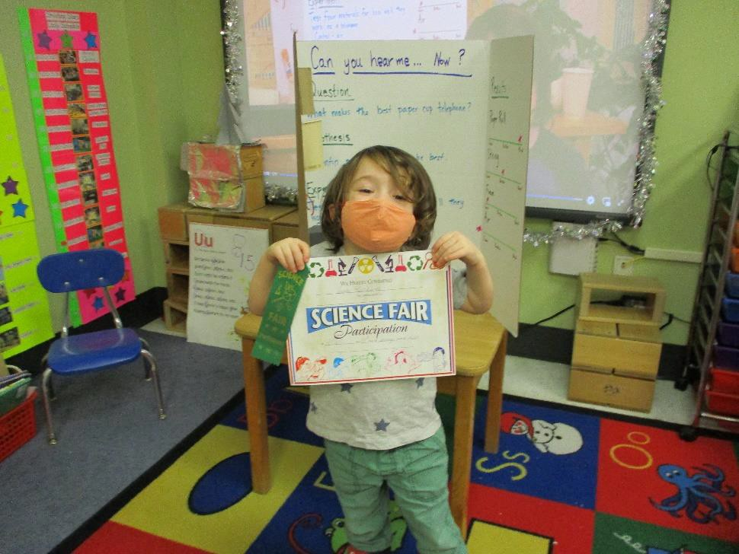
I Am Peace: A Book of Mindfulness by Susan Verde and Peter H. Reynolds

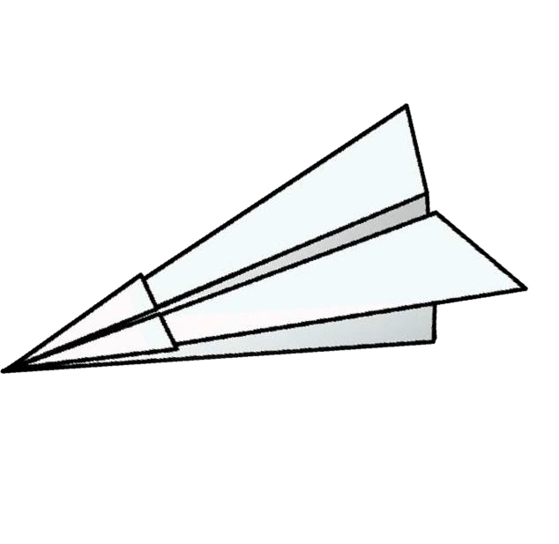

PG County Department of Rec. Present’s Bookworm Garden: 3rd Saturday of every month

Riverdale House Museum https://www.experienceprincegeorges.com/event/bookworm-garden/23377/

Locust Grove Nature Center- Bethesda MD 7777 Democracy Blvd.
https://montgomeryparks.org/special-events/

The Happy Yogi Music and Yoga for Preschoolers
http://thehappyyogi.com/

Friendship Celebrations
Each class will have a friendship celebration on Tuesday, February 14th. See your child’s Teacher for details specific to your child’s class.
Paper Airplane

Contest
GCDC will have a Paper Airplane Experiment/Contest on March 10, 2023. This activity requires parent participation. There are two parts to the experiment/contest
**distance and length of time airborne. **
First children will make paper airplanes in their classrooms with their teachers. We will record their time and distance. Then they will take their planes home and work with parents to determine if they need to start over or just change a few things to improve on their time and distance. Parents must work with their children at home to come up with the best paper airplane design.
Planes must be made of paper only. Please do not use other materials.
Parents should bring the airplanes to school the day of the contest.

Enrollment Intention Forms
Due: April 1, 2023
GCDC currently has 72 children enrolled. We would like to hit an enrollment goal of 78 by Mid-February. We currently have 2 vacancies left in our Preschool 2’s program, 1 vacancy in our Preschool 3’s program, and 2 vacancies in our Preschool 4’s program. Please tell your friends and colleagues to help us hit our enrollment goals.
Enrollment Intention forms will be distributed on March 1st.
Please complete them by the due date to reserve your child’s space for the 2023-2024 school year.
Once we receive all forms, we can begin planning for classroom placements for next year. This data will also help us to determine what spaces we will have available for our summer program.

Newsletter Editor
Leona Adams GCDC Program Director

Contributors: Chanel Trent Keyohna Wallace Lakshini Wijeweera

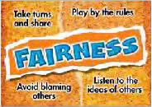

Character Trait of The Month

Postal Worker Visit

Our annual postal carrier visit is scheduled for February 13th. Parents letters to children and teachers are due February 10th. Please provide them at drop off to your child’s teacher or the front office.
The character trait of the month is Fairness. Through studying this character trait, we want children to understand that people of character:
Play by the rules • Take turns and share • Be open-minded; listen to others • Don’t take advantage of others • Don’t blame others
carelessly • Treat all people fairly

January Reflections
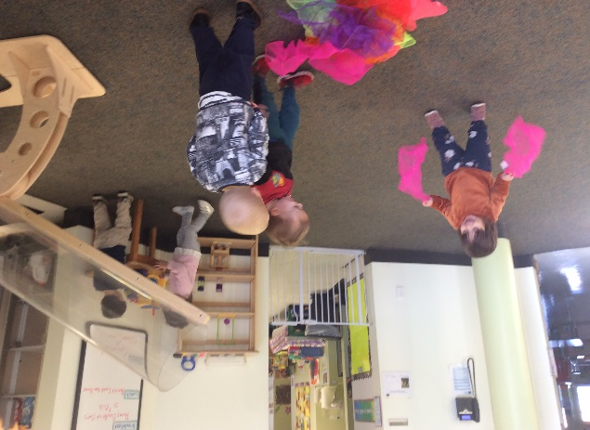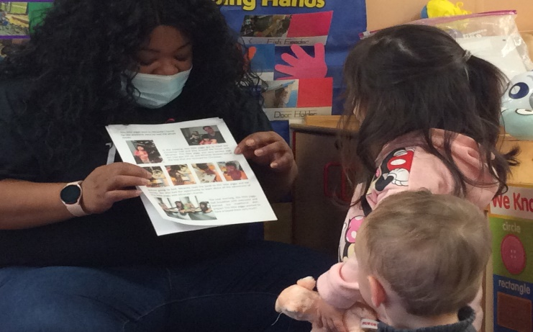

PS 2: Comets
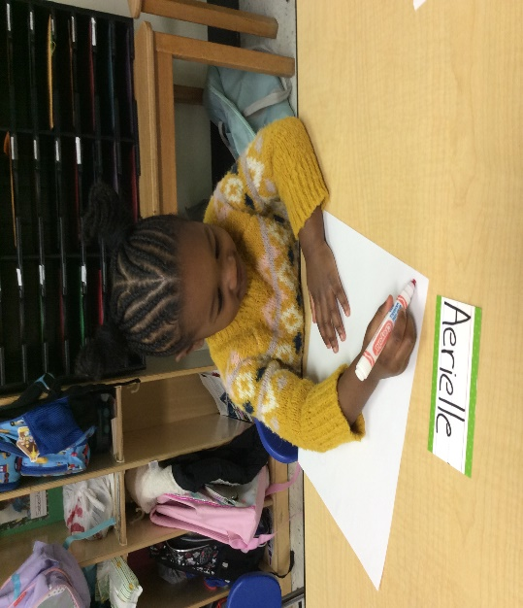
Exploring Wind

PS 3: Milky Ways
Pre-Writing Development

PS2: Comets
Literary Authors
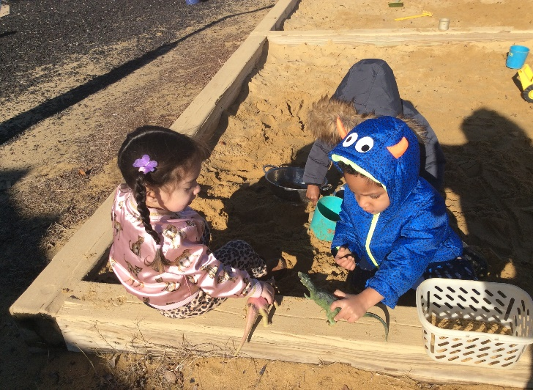

PS 3: Milky Way’s
Sustaining Play w/Peers

Current Volunteer Opportunities:
Technology/Coding Lesson for Pre-K Classes
Create an online Library Catalog System for Teachers
Accreditation Portfolio Support
Organization/Inventory Support
Support Little Dippers with Cleaning Materials

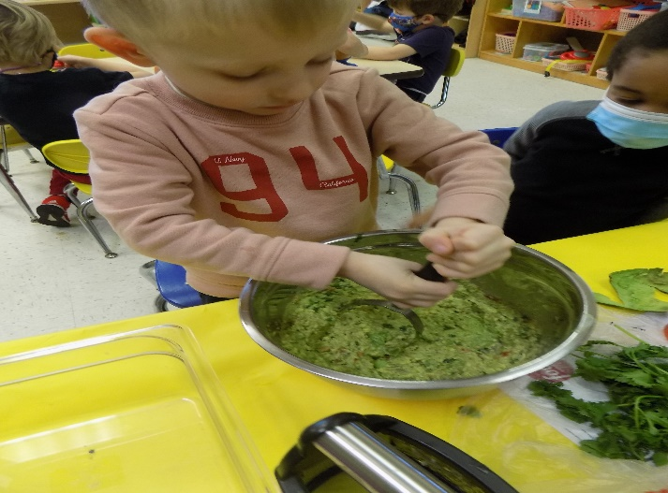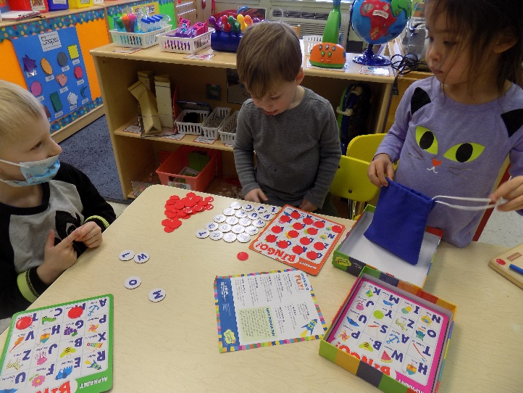
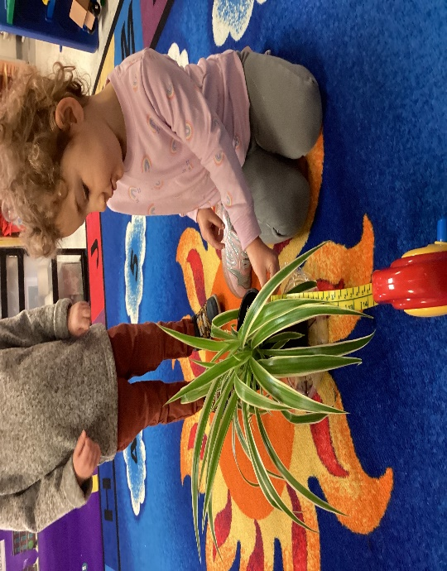

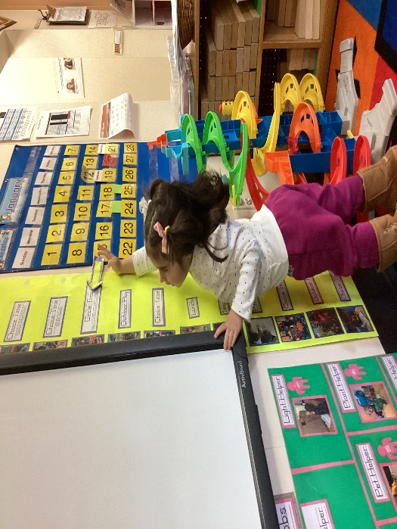
PS4: Shooting Stars
Classroom Cooking

PS 2-3: Little Dippers
Job Helpers

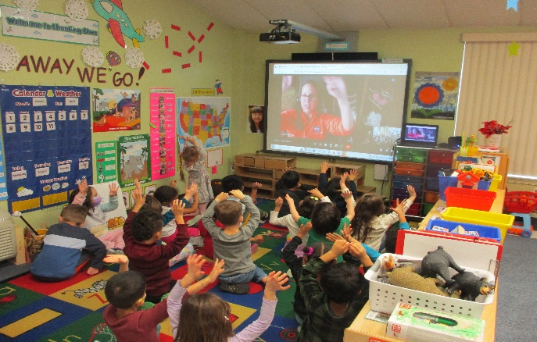
PS4: Shooting Stars

Board Games with Peers

PS 2-3: Little Dippers

Responsibility
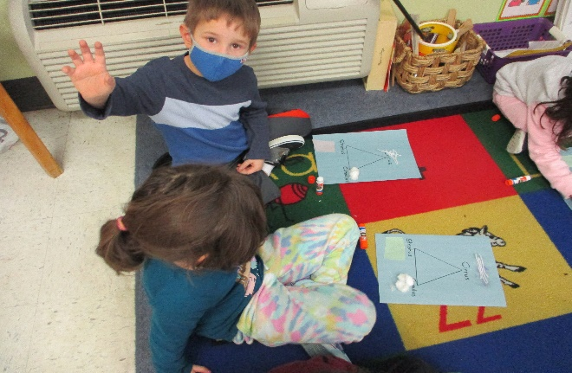

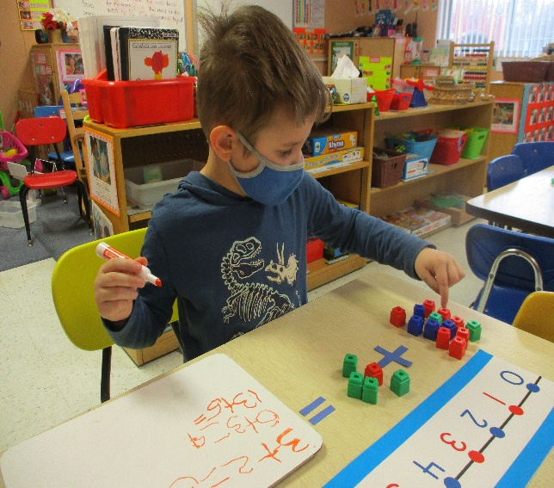
BIG QUESTION OF THE MONTH: (Each child can come to the office to answer the monthly safety question, for participating they can sign the office door and pick a prize)
this month we will begin ASKING SCENARIO questions. HAve you talked with your child about what to do if you ever get seperated? Before asking: Develop the plan you want to introduce to your child. Ex. Stay put, only talk to people with name tags on, Get help from another mom with children. It’s important you describe this all in great detail yet keep the step’s simple. We will then ask the children to describe their safety Plan to an Administrator.
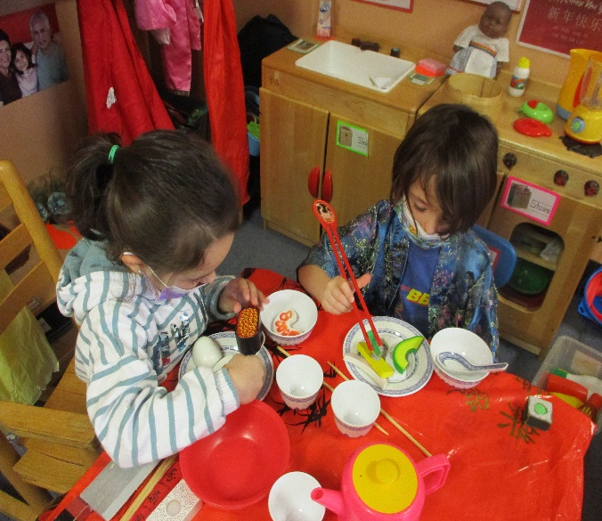

Pre-K: Constellations

Cloud Presentations

Cloud Making

Celebrating Chinese New Year in Dramatic Play

