THE LUNCHBOX PRESS

Nancy Abell Goddard Child Development Center

Jan 2: GCDC Closed

Jan 3: Parent Teacher Conferences
—Comets

Jan 4: Parent Teacher Conferences
—Little Dippers

Jan 5: Parent Teacher Conferences
—Milky Ways

Jan 6: Parent Teacher Conferences
—Shooting Stars

Jan 9: Parent Teacher Conferences
—Constellations

Jan 10: Parent Teacher Conferences
-Constellations

Jan 11: Cloud Presentation (PS4 & Pre-k)

Jan 9: Flat Stanley Projects begins

Jan 9: This Little Piggy Project begins

Jan 16: Federal Holiday—GCDC Closed

Jan 17: Science Fair Begins

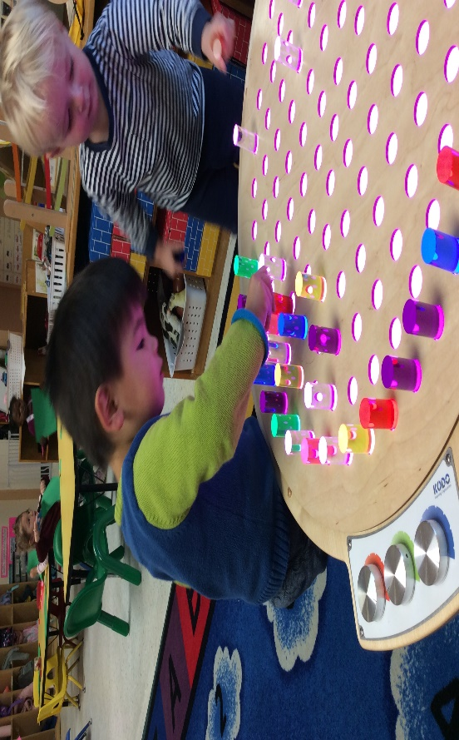

Why Play Matters: The Importance of Learning Through Play by Family Lives
Play is one of the main ways in which children learn and develop. It
helps to build self-worth as it gives children a sense of his or her abilities and helps them to feel good about themselves. Because it's fun, children often become very absorbed in what they are doing.
Play is essential to a child's development; it is an integral part of a
child's early foundation and supports their learning journey. Young children can develop many skills through the power of play. They may
develop their language skills, emotions, creativity, and social skills. Play helps to nurture imagination and give a child a sense of adventure.
Through this, they can learn essential skills such as problem-solving, working with others, sharing, and much more.
In turn, this helps them develop the ability to concentrate. Providing children with a range of playthings will help them learn in many ways:
- Sand and water play can be an early introduction to science and math (e.g., learning that water is fluid, not solid, and that it can be measured in different sized containers). (Continued Page 2)

Association’s Board of Directors 2022–2023

Marilyn Tolliver
President
Martha Wawro
Vice-President
Molly Jackson
Registrar
Claribel Ferrolino
Treasurer
James Harrington
Education Advisor
Jeff Steir
Facilities Advisor
Erin Roberts
Secretary
Brad Cenko
Member At Large
Stephanie Arcido
Member At Large
Robin Mahoney
Acting GEWA Operations Manager

Continued From Page 1

- Playing with dough or clay, drawing, and painting pictures, dressing up, playing with dolls can encourage creativity, imagination, and expression of feelings.

- Building blocks, jigsaws, and shape sorters can help with recognizing different shapes and sizes, putting things in order, and developing logic.

- Playing ball games, dancing, running, climbing all help to improve body movement, strength, flexibility, and coordination skills.

- Games support with turn-taking, sharing, and mixing with others.

- Singing, playing simple musical instruments help to develop rhythm, listening and hearing.

It's vital that learning is fun at this age. It needs to be about doing things that children enjoy. They might find unusual ways of doing things - for a toddler, building blocks aren't just for making towers, and paint can be used without a brush! Show them how things work, but if they want to experiment, let them.

Children learn through all their senses through taste, touch, vision, hearing, and smelling. They will watch those around them and copy language and behavior.

Newsletter Editor:
Leona Adams
Program Director
Newsletter Contributors:
Laura McKeon
Nahara Ortiz-Nieves
Keyohna Wallace
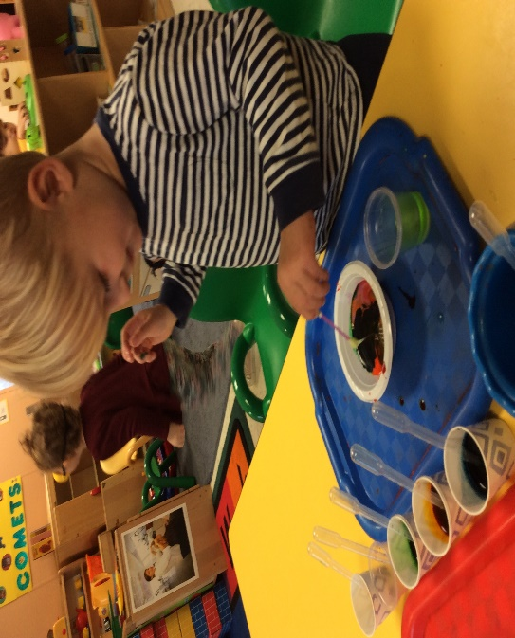
Don't push your child too hard. Children develop in their ways and in their own time. Try not to compare them to other children. You can also encourage reading by reading to and with them. Look at the pictures together; this will help younger children make sense of the words.

It's also good to talk to them a lot about everyday things while you are cooking or cleaning. This will give you a chance to teach them how things work, and they will be able to ask you questions. Get ready for lots of "why's?"

Big Question of the month
What is my Phone Number?
Teaching your child important emergency information will help keep them safe during an emergency.

Teach your preschooler your phone number in 6 easy steps:
- Match it up. First show your child the phone number. ...
- Clap it out. ...
- Sing it. ...
- Make it big on a wall. ...
- Stomp it out. ...
- Practice on a real phone

School Applications: At this time of year, parents may request Teachers complete forms in support of applications to other schools. Parents must
submit these requests and addressed/stamped envelopes to our Assistant Director, Ms. Elycia Chew. Once the Teacher completes the forms, they will return the forms to Ms. Elycia, who will, in turn, mail the paperwork directly to the requesting school. Neither the paperwork nor the copies are given directly to the parents. Please allow two weeks for this process. We understand that families may have several prospective schools for their child; however, we are not able to support more than four requests per child.
NEWS FROM THE BUSINESS MANAGER
- Catalog New Books for the Library
- STEM Presenters
- Accreditation Portfolio Support
- Blow Rubber Mulch/Blue Top (Must have a leaf blower)
- Photographers (3 ppl) for Science Fair
- Teach a Yoga Class (5 classes- half hour per class)

HAPPY NEW YEAR! It is that time of year when GCDC provides year end statements for all families. We are working on emailing these documents out and will have them delivered to families via email by 1/31/23.

All families are required to complete 4 hours of volunteer time by 12/31/22. Volunteer hours are being counted, billing for all unmet hours will occur by 1/31/23.

Character Trait of The Month

Through studying this character trait, we want children to understand that a person of character:

Treats others with respect • Are tolerant and accepting of differences • Use good manners, not bad language • Are considerate of the feelings of others • Do not threaten, hit, or hurt anyone • Deal peacefully with anger, insults, and disagreements.

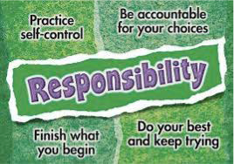

Parent Teacher Conference Schedules are posted in the classroom doorways. If you have not signed up, see your child’s Teacher as the online sign-up deadline has passed.
Comets (Jan 3)
Little Dippers (Jan 4) The Milky Way (Jan 5) Shooting Stars (Jan 6) Constellations (Jan 9)
Constellations(Jan 10)
This Photo by Unknown Author is licensed under CC BY-SA
GCDC Annual Parent Child Science Fair
Our children are getting use to virtue or remote learning as a part of their everyday world. Science projects are an excellent choice for STEM learning. Just doing and turning in the project isn't always enough. A science fair adds an important layer to the hands-on learning for young children when they know they will be presenting to their peers.

- Sign Up for a time slot to present
- Pick up your poster board from GCDC
- You may choose to create a video on the private class Facebook page to be viewed during your time slot.
- Pick a topic
- Do your research
- Develop a Hypothesis
- Conduct your experiment
- Construct an exhibit (prepare poster board)
- Present for your class or submit a Video presentation

Great age-appropriate science fair activities can be found at the link below for those of you who may need a little inspiration.
https://funlearningforkids.com/science-activitiespreschoolers/

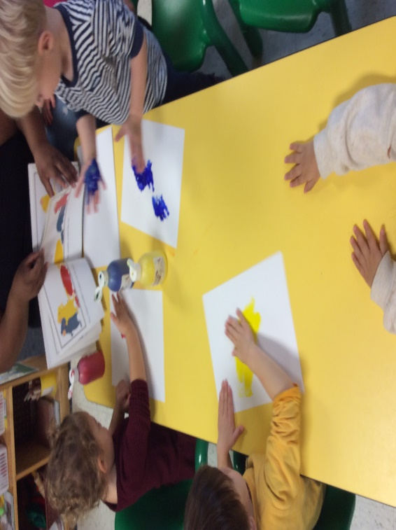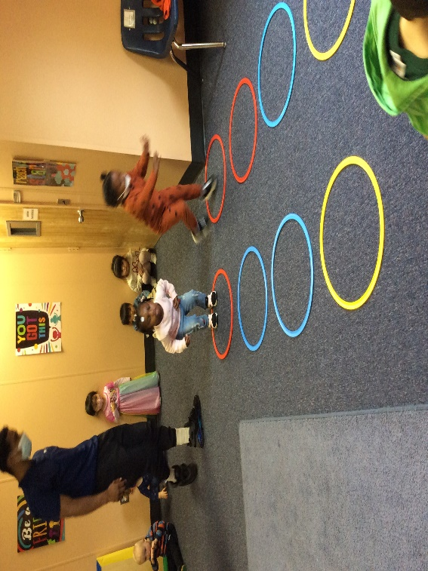

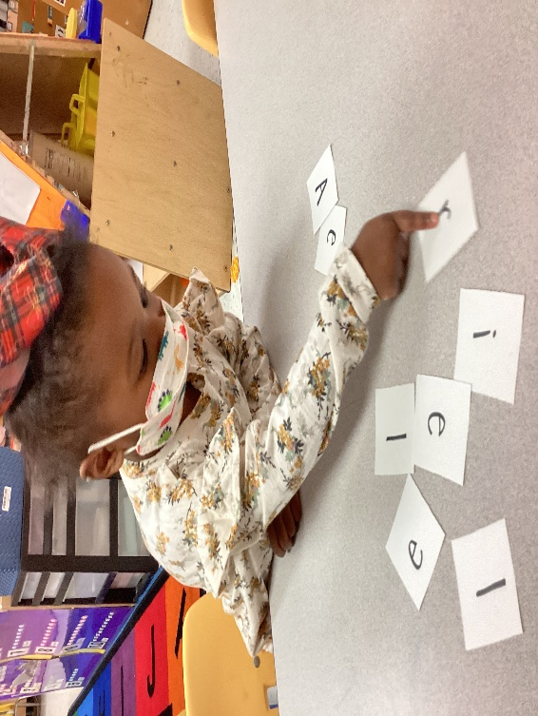
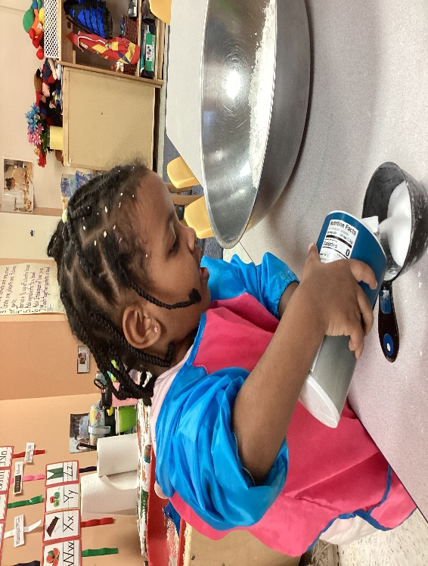
Comets (Preschool 2) Appreciation of Art Comets (Preschool 2) Large Motor Development

Little Dippers (Preschool 2) Science/Art Little Dippers (Preschool 2) Literacy
Congratulations to Ms. Alexis, Ms. Elycia and Ms. Leona for earning their 45-hour Infant/Toddler Certification. This credential is widely recognized in the state of Maryland for early childhood professionals that work with children from birth-36 months. This credential is required for ECE professionals that want to pursue a CDA credential or higher credential level through MSDE. To obtain this credential, applicants must demonstrate their competency in areas that support the healthy growth and development of children.

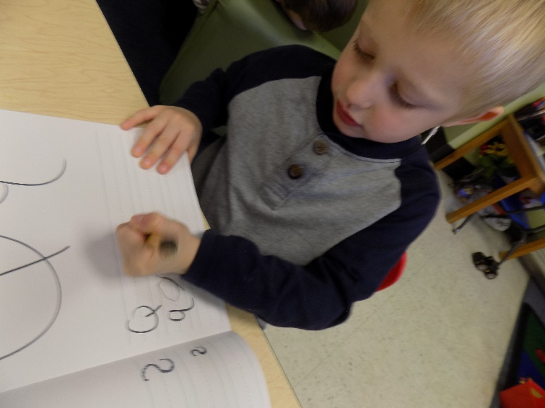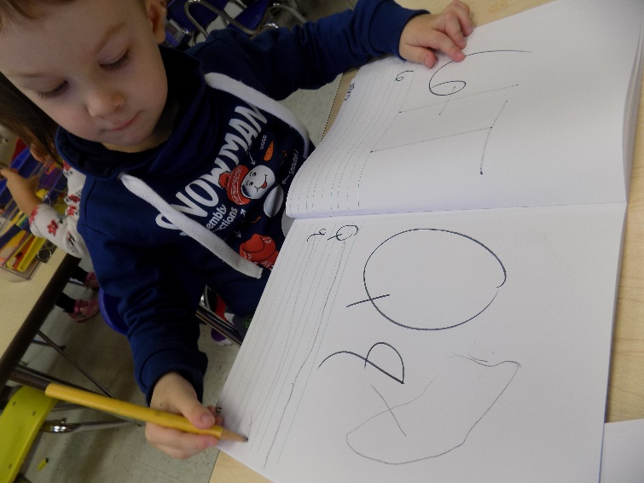

Shooting Stars (Preschool 4) Journal Writing Shooting Stars (Preschool 4) Fine Motor Skills

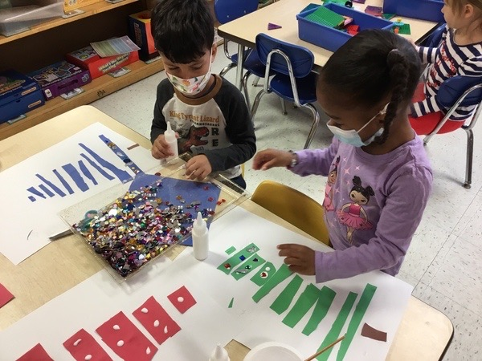
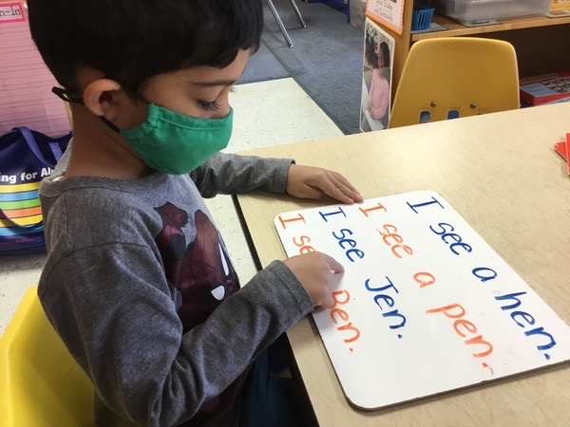

Constellations (Pre-K) Emergent Reading Constellations (Pre-K) Classification with Friends

Classes serving children ages 3 and up will participate in a project based upon the book Flat Stanley. The story goes like this:
Stanley Lambchop and his younger brother Arthur are given A big bulletin board by their father to display pictures and posters. He hangs it on the wall over Stanley’s bed. During the night, the board falls from the wall flattening Stanley in his sleep He survives and makes the best of his altered state. Soon, he is entering lock rooms by sliding under the door and playing with his younger brother by being used as a kite. One special advantage is that Flat Stanley is tired of being flat and Arthur changes him back to his proper state with a bicycle pump.
Each student will create his/her own Flat Stanley in class. They will need to be mailed. Once the project begins, parents are asked to talk with their children and help them decide where to mail their Flat Stanley.

A letter will be placed inside the envelope explaining to the recipient what they should do with Flat Stanley. Basically, they are to take Flat Stanley to a special location or do a special activity with the visiting Flat Stanley. Because these are young children, we will ask that the letters be mailed back to the parents. It is important that you pick someone that will play along. The letters will be opened by the Teachers. Students will track all of Stanley’s destinations on a map/globe. This project provides a unique opportunity for authentic literacy as well as to learn about geography.

More details will come from the teachers soon.

The Child Care Crisis is Getting Worse!
High turnover and staffing shortages have long been a scourge of early childhood education, but for many childcare providers, the struggle has ratcheted up considerably during the pandemic and remains true now. GCDC has not been exempt from this challenge. We continue to find creative ways to attract qualified candidates and retain current staff; however, our efforts are only slightly moving the needle. We manage our budget sharply in order to offer competitive/higher salaries and benefits. We are creative with providing incentives of recognition, as well as time off awards, tuition reimbursement and bonuses. We have struggled to find quality teachers since reopening in October of 2021. GCDC hasn’t returned to full capacity since March 2020, when we shut down for what would be almost 18 months. Since reopening, we have been trying to build back our staff and enrollment. Enrollment continues to increase as more families return to the work force. We went from 3 open classes in 2021 to 5 open classes in 2022 and still growing with a lengthy wait list for our youngest age group; however, the issue is not the virus any more it’s staffing. Without staffing GCDC simply cannot open up more classrooms at this time and have decided that transitions midyear provide better opportunities to meet the needs of our current mixed age groups, waitlist members and retaining teachers. Child Care programs and providers all over the country, regardless of their state or setting, are experiencing the strain of being understaffed. You can read more about the current nationwide crisis using one of the links below:
https://www.nytimes.com/2022/10/13/us/child-care-worker-shortage.html
https://www.vox.com/policy-and-politics/2022/9/27/23356278/the-pandemic-child-care-inflation-crisis
https://abcnews.go.com/US/child-care-industry-struggles-shortage-workers-unheard/story?id=91701041
https://finance.yahoo.com/news/staff-shortages-crippling-childcare-centers-201534309.html
https://www.americanprogress.org/article/the-child-care-sector-will-continue-to-struggle-hiring-staff-unless-it-creates-good-jobs/
https://www.usnews.com/news/national-news/articles/2022-05-10/child-care-industry-struggling-two-years-into-the-pandemic
https://www.washingtonpost.com/business/2021/05/26/child-care-center-worker-shortage/

