THE LUNCHBOX PRESS

**NASA Goddard Child Development Center**

GCDC’s philosophy is to meet children’s developmental and individual needs and to create a stimulating environment in which children learn through exploration and discovery.

### 

**Upcoming Events**

**May 4-7**

Conference By Sea

**May 8-12**

Staff and Teacher Appreciation Week

**May 11**

Spring Picture Day

**May 12**

Parent Teacher Conference Sign Up

Program Tour

**May 18**

Parent Child Egg Drop

**May 19**

Report Cards Released

**May 26**

Staff Professional Development

(Closed for Service)

**May 29**

Closed for Memorial Day

**May 30**

Comets P/T Conferences

**May 31**

Dippers P/T Conferences

**June 1**

Milky Way P/T Conferences

**June 2**

Parents Day Celebration/Art Show

**June 5**

Stars P/T Conferences

**June 6 & 7**

Constellations P/Teacher Conferences.

**June 9**

Field Trip to National Zoo

**June 16**

End of the Year School wide Picnic and Field Day

### Elements of Exercise

*By Kids Health*

When most adults think about exercise, they imagine working out in the gym on a treadmill or lifting weights. But for kids, exercise means playing and being physically active. Kids exercise when they have gym class at school, soccer practice or dance class. They’re also exercising when they’re at recess, riding bikes or playing tag.

### The Many Benefits of Exercise

Everyone can benefit from regular exercise. Kids who are active will:

* have stronger muscles and bones
* have a leaner body, because exercise helps control body fat
* be less likely to become overweight
* decrease the risk of developing Type 2 Diabetes
* possibly lower blood pressure and blood cholesterol levels
* have a better outlook on life

In addition to the health benefits of regular exercise, kids who are physically fit sleep better and are better able to handle the physical and emotional challenges that a typical day presents — be that running to catch a bus, bending down to tie a shoe, or studying for a test.

*Continued Page 2*



**Volunteer Opportunities**

1.Clean/Polish Tea Sets

2. Exercise/Yoga instructor support

3. Cleaning up Mulch on Upper Playground

4. Conducting Science Experiments for STEAM Camp

5. Guest Speakers for STEAM Camp

6. Toy Shed Inventory Support

7. Library System Support

**If interested, in any jobs above please contact a GCDC Administrator**. **Please see other volunteer opportunities on your classroom sign up.**

**Comets** <https://signup.com/go/MxzBiYi>

**Dippers**

<https://signup.com/go/yjypPYk>

**Milky Way**

<https://signup.com/go/ORqzYDM>

**Shooting Stars**

<https://signup.com/go/Nfkaxis>

**Constellations**

<https://signup.com/go/VNZSvCn>

*Continued from Page 1*

### The Three Elements of Fitness

If you’ve ever watched kids on a playground, you’ve seen the three elements of fitness (e.g., endurance, strength, and fitness) in action when they:

1. Run away from the kid who’s “it” (endurance)
2. Cross the monkey bars (strength)
3. Bend down to tie their shoes (flexibility)

Parents should encourage their kids to do a variety of activities so that they can work on all three elements. **Endurance** develops when kids regularly engage in aerobic activity. During aerobic exercise, the heart beats faster and a person breathes harder. When done regularly and for continuous periods of time, aerobic activity strengthens the heart and improves the body’s ability to deliver oxygen to all its cells.

Aerobic exercise can be fun for both adults and kids. Examples of aerobic activities include basketball, bicycling, ice-skating, in-line skating, soccer, swimming, tennis, walking, jogging, and running.

Improving **strength** doesn’t have to mean lifting weights. Although some kids benefit from lifting weights, it should be done under the supervision of an experienced adult who works with them. But most kids don’t need a formal weight-training program to be strong. Push-ups, stomach crunches, pull-ups, and other exercises help tone and strengthen muscles. Kids also incorporate strength activities in their play when they climb, do a

handstand or wrestle.

Stretching exercises help improve **flexibility**, allowing muscles and joints to bend and move easily through their full range of motion. Kids look for opportunities every day to stretch when they try to get a toy just out of reach, practice a split or flip over the couch.

### How Much Exercise Is Enough?

Parents need to ensure that their kids get enough exercise. So, how much is enough? As a general guideline, all children 2 years and older should get at least 60 minutes of moderate to vigorous exercise every day. The National Association for Sport and Physical Education (NASPE) offers specific recommendations for kids:

* **Infant**—No minimum daily activity requirements. Physical activity should encourage motor development.
* **Toddler**—Minimum daily activity requirement: 1.5 hours. 30 minutes planned physical activity and 60 minutes unstructured physical activity (free play)
* **Preschooler—**Minimum daily activity requirement: 2 hours. 60 minutes planned physical activity and 60 minutes unstructured physical activity (free play)
* **School Age—**Minimum daily activity requirement: 1 hour. Break up into bouts of 15 minutes or more

The U.S. Department of Agriculture’s revised Food Guide Pyramid lets parents enter a child’s age, gender, and activity level to get recommendations for total calories and healthy eating.



# GCDC is Going to the Washington National Zoo

1. **Where-** The Smithsonian National Zoo 3001 Connecticut Ave., NW Washington, DC 20008

For more information please visit: <https://nationalzoo.si.edu/>

1. **When**- June 9th, 2023
2. **Time-** 9 am-3 pm
3. **Transportation**- Middledorf Bus Company Inc.– Transportation is included for students, staff and chaperones traveling with the GCDC. 4 Buses with a capacity of 50 ppl per bus. Space is limited to students, staff and identified chaperones.
4. **Lunch Requirements**- Students must have a completely disposable lunch. Chaperones and teachers will only carry brown bag lunches, tissue, gloves, small first aid kit and emergency medications. Everything will be thrown away after lunch.
5. **Chaperone**- Chaperones must use a backpack, so that they are hands free to support children. All children that ride the bus must return on the bus



**Don’t Forget to Download Your Child’s Portfolio**

Parents of all non-continuing students are encouraged to download all data from their child’s Teaching Strategies GOLD portfolio by **June 30, 2023**.

After this time, we will delete your child’s information to make room for newly enrolling students. Once the data has been deleted, it cannot be recovered.

.





The GCDC Association’s Board of Directors is now accepting nominations for the 2023-2024 School Year. Please consider

supporting our program by running for the GCDC Association’s Board of Directors.

Both currently enrolled and wait-listed parents are eligible to serve on the board.

Positions up for election are Vice President, Registrar and Members-At-Large (2 Positions).

To learn more about each position, visit [www.gcdcnasa.org](http://www.gcdcnasa.org) On this page, parents may self-nominate or nominate another parent.

**Nominations Due May 30th**

For more information, contact the GCDC Association’s Registrar, Molly Jackson @ [Molly.i.jackson@nasa.gov](mailto:Molly.i.jackson@nasa.gov)

**2022-2023 GCDC Association’s Board of Directors**

**Marilyn Tolliver**

President

**Martha Wawro**

Vice-President

**Molly Jackson**

Registrar

**Delores Dune**

Treasurer

**James Harrington**

Education Advisor

**Jeff Steir**

Facilities Advisor

**Erin Roberts**

Secretary

**Brad Cenko**

Member At Large

**Stephanie Arcido**

Member At Large

**Robin Mahoney**

GEWA Operations Manager





**Transition Talks**

Moving on to a new classroom and Kindergarten especially are important life events. Preschoolers can feel excited-and a bit worried, too. Families have similar feelings, knowing their child is going to “big school”. Here at GCDC the Admin Team support the transition process for children by having a daily meeting with our transitioning children. We read a specific series of books and talk about what to expect. We talk about their feelings and have opportunities to talk about their fears.

Transition Talks begin June 13th, 2023.

**Join us for 0ur 2023 Parents Day Celebration and Art Show**

**June 2nd, 2023**

**Comets 3:15**

**Dippers 3:15**

**Milky Way’s 3:30**

**Shooting Stars 4:00**

**Constellations 4:20**



Beginning May 8th, 2023, all children’s lunches brought from home will need to include food from each food group. As an accredited and licensed program GCDC needs to adhere to NAEYC performance standards and the USDA regulations for meal requirements for children.

The lunch will need to include:

* A Meat or Meat Alternative
* ONE vegetable AND ONE Fruit OR TWO vegetables (2 different choices)
* One Whole Grain (pasta, biscuit, roll etc.)
* Fluid Milk 6 oz. (which GCDC provides) yogurt cannot be substituted for milk.

Check the link below for healthy ideas of meals you can pack for your child:

<https://www.naeyc.org/resources/blog/lets-eat-well>

If one of these components is missing in your child’s lunch, we will supplement the component that is missing. A “Missing Meal Component Notification” will be sent home and your account will be billed in the amount of $10.00 per food item provided by GCDC. Fees will increase with the frequency of missing items, as GCDC cannot afford to provide full lunches for children.

This has always been our policy but was suspended during Covid. We are happy to be moving in the direction of compliance.

Please save cookies, candy, chocolate, cake etc. for home, as those are treats and we teach the children that they are Sometimes Foods.

We are giving you notice before it becomes effective next week as that will give you time to go grocery shopping to stock up on Always Foods.

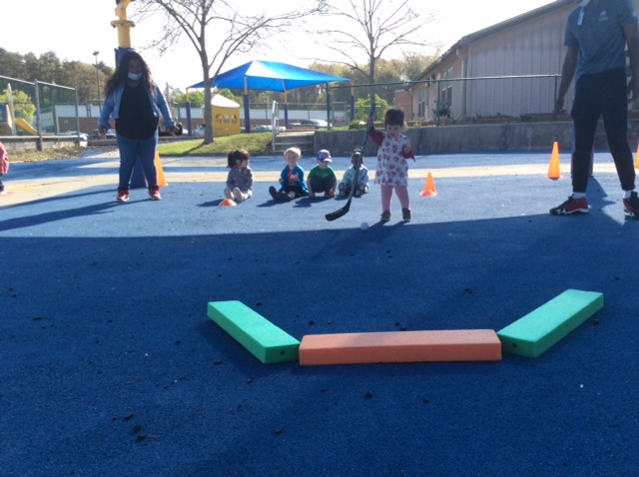 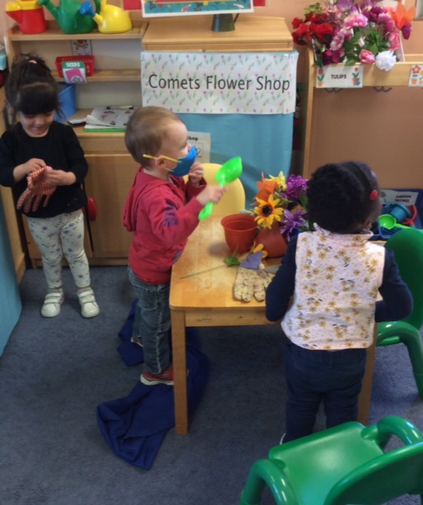

## PS2: Comets

Obstacle Course

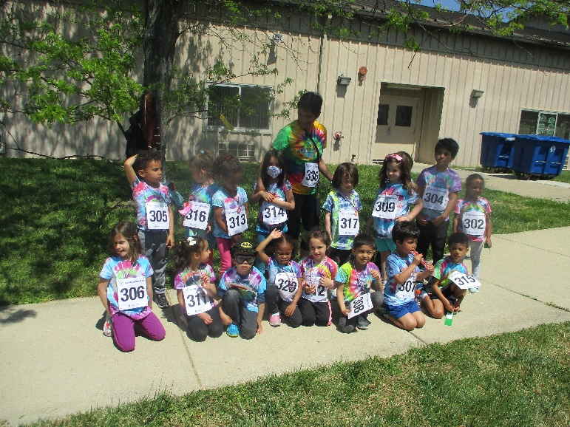

## Pre-K Constellations

2 Mile Fun Run & Gardening

## PS2: Comets

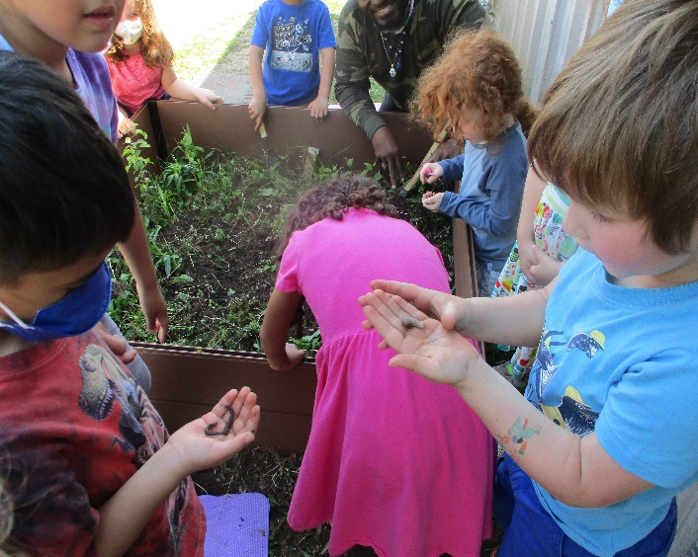 Dramatic Play with Peers



## Parent and Child Event—The Great Egg Drop May 18th, 10:00 a.m.

**Building 26**

Participants: Open to all Pre-K families The Great Egg Drop is an experiment where each parent and child team attempts to create a device that can keep a raw chicken egg intact when dropped from a height. Each parent and child team will need to create something that can absorb the energy the egg gathers as it accelerates towards the ground. To sign up, please visit your classroom signup.

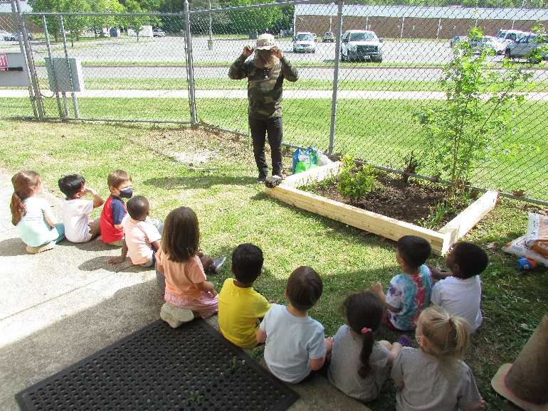 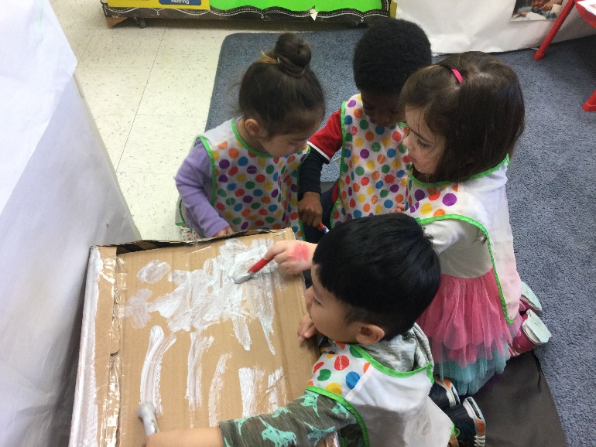

## PS3: Milky Way

## Outdoor Education

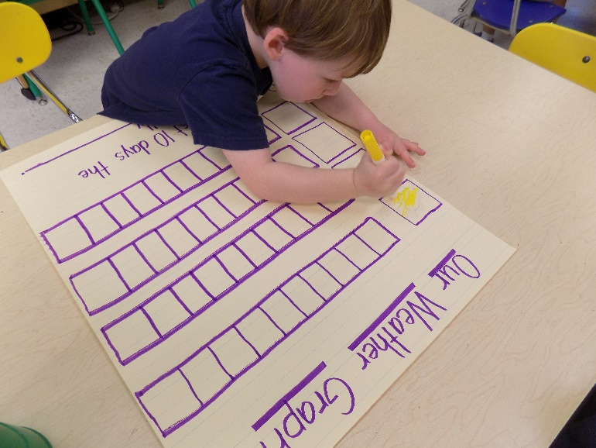

## PS4: Shooting Stars

Graphing

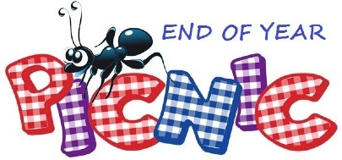

## PS3: Milky Way

Collage Art

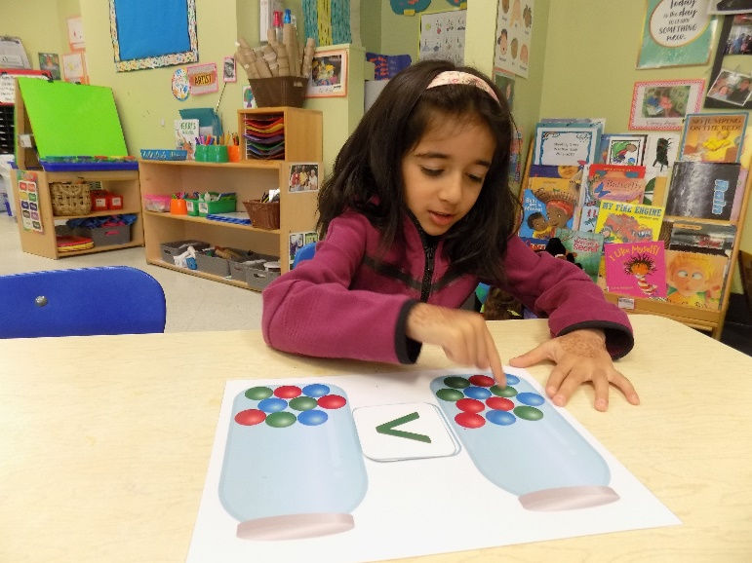

## PS4: Shooting Stars

More Than, Less Than, Equal To

**Save The Date 2023 End of Year Picnic**

**June 16, 2023**

**School Reference Forms**

It is that time of year when parents of graduating students often request that GCDC Teachers complete various forms in support of applications to other schools.

These requests and addressed/stamped envelopes must be submitted to our office.

Once the Teacher completes the forms, the forms are mailed directly to the requesting school. Neither the forms nor the copies are given directly to the parents.

Please allow two weeks for this process.

We understand that families may have many prospective schools for their child; however, we can only support four requests per

child.



**Spring Picture Day**

**May 11, 2023**

**9:30 A.M.**

**Parent Teacher Conference Sign Up Links**

**Comets**

<https://signup.com/go/fHaLOys>

**Dippers**

<https://signup.com/go/QQHxJPT>

**Milky Ways**

<https://signup.com/go/kPCjUoq>

**Shooting Stars** <https://signup.com/go/HpNyLUu>

**Constellations** <https://signup.com/go/yCqCXoE>

A huge congratulations to Ms. Lakshini for being selected to receive the Terri Lynne Lokoff/Children’s TYLENOL® National Child Care Teacher Award.

This award acknowledges the critical role of childcare teachers in providing quality early care and education. Childcare teachers from all 50 states, the District of Columbia and on U.S. Military bases and installations around the world were invited to apply.