PARENT FAQS

We are excited to offer automatic payments through Tuition Express. It is no longer necessary for you to write a check for tuition and fees. Your bank or credit card account will be safely and securely debited by Tuition Express. You can be emailed a receipt for each transaction. It’s easy to sign up – just ask us.
Frequently Asked Questions

When I pay my tuition automatically, how secure is my account information?
Very secure – more secure than when you write checks. The checks you write every day have your name, address, phone number, and sometimes your driver’s license number on them. With this information, criminals have all they need to access your account or worse, steal your identity. Automatic payments greatly reduce this potential problem by limiting the amount of information available and who has access to it. Tuition Express also incorporates additional security procedures, utilizing 128-bit encryption.
What if the child care center makes a mistake and takes out too much money?
Report the error to your child care center immediately – it was most likely an honest mistake. The child care center will then adjust your account accordingly.
What if my child care center and I disagree about a payment?
Copyright Procare Software 12-13-2013
If you feel that the payment should not have been made, you have the right to dispute the charge. Contact your bank or credit card company. Tuition Express and your child care provider will work closely to resolve the issue in a timely manner.
Convenient and Safe
On-time Payments
Does this form of payment give the child care center access to my account?
Nobody at the child care center has access to your account. When you sign up for Tuition Express, you only authorize your bank or credit card company to release the exact amount owed to your provider, when it is due and payable.
How will I know when a payment was taken out of my account?
Your child care expenses will be taken out of your account on a schedule that you and the child care center agree upon. Your child care center has the ability to print statements for your records, prior to the withdrawal of any money. Additionally, the charges will show up on your monthly statement as “Tuition Express”.
When I sign up for Tuition Express, how will this help my child care provider?
Your child care provider has chosen to offer automatic payments for several reasons. First, it will give you the convenience of not having to write a check every time tuition and fees are due. Second, it allows regular scheduling of your payments. Most importantly, automatic payments reduce the amount of time your child care center spends on management activities, giving staff more time to spend with the children.
How do I get started?
Simply complete the “Payment Authorization” form and return it to your child care provider. They will do the rest!
Where can I learn more?
For more information on the benefits of Tuition Express, please visit us at www.tuitionexpress.com.

We are excited to offer the safety, convenience and ease of Tuition Express®–a payment processing system that allows secure, on-time tuition and fee payments to be made from either your bank account or credit card.

ELECTRONIC FUNDS TRANSFER AUTHORIZATION FOR BANK ACCOUNT and CREDIT CARD
I (we) hereby authorize (business name) ____________________________________________ to initiate credit card charges to
the below-referenced credit card account (Section A) OR, initiate debit entries to my (our) checking or savings account, indicated below (Section B). To properly affect the cancellation of this agreement, I (we) are required to give 10 days written notice. Credit union members: please contact your credit union to verify account and routing numbers for automatic payments. Check with the center for accepted credit card types.
COMPLETE ONE SECTION ONLY

SECTION A (Credit Card)
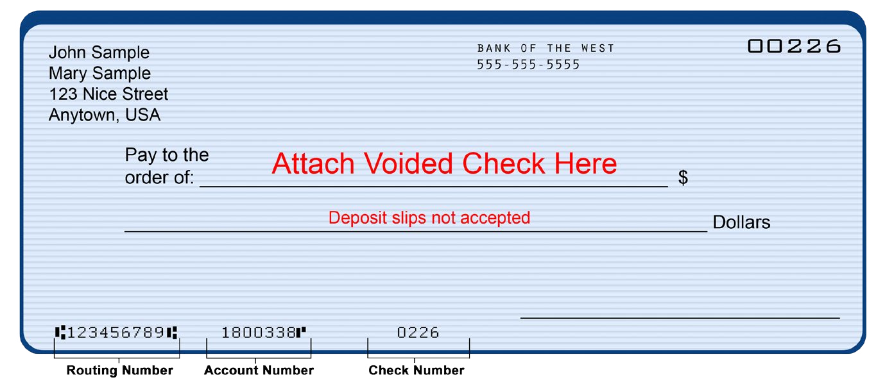
_______________________________________________________________________________________________________
Address

State

Zip

City

_______________________________________________________________________________________________________
Bank or Credit Union Name

Bank or Credit Union Address

City

State

Zip

_
______________________________________________________________________________________________________

Routing Transit Number (see sample below)
Account Number (see sample below)
_______________________________________________________________________________________________________

Date

Authorized Signature

For Official Use Only
Date Received
________________________
Employee Signature
________________________
A service of
Checking
Savings
Copyright Procare Software 1/16/2015
Automated Payment Processing
Safe – Convenient – Easy
Cardholder Name Phone #
_______________________________________________________________________________________________________
Cardholder Address City State Zip

_______________________________________________________________________________________________________
Account Number Expiration Date
_________________________________________________________________________________________________________________________________
Cardholder Signature Date

SECTION B (Bank Account)
_______________________________________________________________________________________________________
Your Name Phone #
_______________________________________________________________________________________________________ We are excited to offer the safety, convenience and ease of Tuition Express Online Payments. You can process on-time tuition and fee payments with your credit card at www.tuitionexpress.com
TUITIONEXPRESS.COM REGISTRATION
As a customer of _____________________________________________(business name), I (we) wish to register at www.tuitionexpress.com for the purpose of making Online Payments using a credit card.
PLEASE CONTACT CENTER REPRESENTATIVES FOR CREDIT CARD TYPES ACCEPTED BY CENTER.
_______________________________________________________________________________________________________
Automated Payment Processing
Safe – Convenient – Easy
For Official Use Only
________________________
Date Received
________________________
Employee Signature
A service of
Copyright Procare Software 11/04/2014
Cardholder Name Phone #
_______________________________________________________________________________________________________
Cardholder Address City State Zip

_________________________________________________________________________________________________________________________________
Cardholder Signature Date
Website Registration Code: __________ (Please select a 4 digit PIN that will be used when you register at TuitionExpress.com)
4 digits

